0

 **CURICULUM VITAE**

1. **Personal Details**

Name : Budi Hartono

Place, Date of Birth : Jambi, 14 September 1990

Marital Status : Menikah

Religion : Buddha

Education : Strata 1 – Teknik Informatika

IPK : 3,55/4

Address : Jl. Ismail Malik Rt. 35 Kel. Mayang Mangurai, Jambi

No. Handphone : 085211439555

Email : Budh1_9999@yahoo.com

1. **Profile**
   1. Meticulous, attention to things in detail
   2. Discipline, time management oriented
   3. Easy to adapt and socialize with their surroundings
   4. Be reliable, able to work with team members
   5. Loyalty to the job
   6. Unyielding face problems
   7. Enthusiastic in learning about new things and quickly learned
2. **Education Background**

A Bachelor’s degree from STIKOM DINAMIKA BANGSA JAMBI, Indonesia. June 2008 – March 2012.

1. **Skills/Co-curriculum**
2. Utilize Microsoft Office 2007 & 2010 (Excel, Power Point, Word, Etc)
3. SAP Payroll System, SAP Time Management System and SAP Cost Control System
4. AS400 Time Management System
5. Hardware Computer
6. Foxpro Accounting System
7. Key Performance Indicator System (E-PASS)
8. Kader Norma Ketenagakerjaan Muda
9. VHP HR System
10. **Work Experience**
11. PT. Sabak Indah, April 2011 – July 2012

Job Position : Staff Accounting

Duties:

1. Monthly report journal

2. Monthly report petty cash

3. Monthly report ledger and subledger

4. Reconciliation factory employee salary every month

5. Reporting and tax payment pph 21

6. Check opname material spare part and audit asset in the factory

7. Report VAT in and VAT out, pph 15, pph 23

1. PT. Rimba Hutani Mas, Juli 2012 – Februari 2014

Job Position: Staff Human Resource Departement

Duties:

1. Payroll and Salary Slip

2. Report, control and payment tax pph 21

3. Employment BPJS

4. Health Insurance

5. Time management employee

6. Report premium employee

7. Report Key Performance Indicator (KPI) Departement

8. Report, control and payment of overtime employee

9. Handling 800 employee

1. PT. Rimba Hutani Mas, March 2014 – October 2014

Job Position: Staff Cost Control

Duties:

1. Report capital expenditure departement

2. Audit asset in distric

3. Posting payment of company asset (example: building repairs dll)

4. Control the numbering of corporate assets

5. Review achievement key performance indicator Accounting

6. Closing asset every month

7. Control of company assets

8. Handling 7 company

1. Aston Jambi Hotel & Conference Center, November 2014 – Present

Job Position : Human Resource Supervisor

Duties:

1. Report, control and payment of overtime employee

2. Industrial relation

3. Recruitment employee

4. Report and control time management employee

5. Report, control and payment of employee meals

6. Payroll and salary slip

7. Report, control and payment of BPJS ketenagakerjaan & BPJS kesehatan

8. Report, control and payment of tax pph 21

9. Payroll Tax Employee Related Report

10. Payroll Tax Employee Benefit Report

11. Control and made an agreement with outsourcing vendor

12. Report new employee and resign employee every month

13. Creating a new labor agreement to employee

14. Report achievement training and report training plan every month

15. The presentation of the achievement of human resource and human resource plan (Example: time management employee, report payroll tax employee related, report payroll tax employee benefit, employee meals, manning & budget employee, report training) every month.

16. Control achievement and budget human resource departement every month

17. Preparing and report budget human resource department

18. Report best employee assessment per 3 months and best employee of the year

19. Report and control of company assets

20. Control and manage the licensing of hotel and office

21. Controlling employee mess facilities and equipment office supplies

1. **References**
2. Name : Mr. I. Gst. Ngr. Arya Wirawan

Position : General Manager

Telephone : 08123858858

Company : The Atrium Hotel & Resort Yogyakarta

Email Address : [Wira1212@gmail.com](mailto:Wira1212@gmail.com)

2. Name : Mr. Aries Supriadi

Position : HR Manager

Telephone : 08127405212

Company : Aston Jambi Hotel & Conference Center

Email Address : [Jambihrm@astonhotelsasia.com](mailto:Jambihrm@astonhotelsasia.com)

3. Name : Mr. Faisal Fotocopy KTP

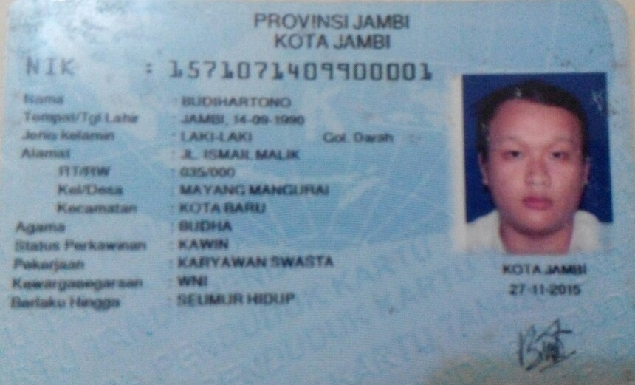 Position : People Development Head

Telephone : 082371109415

Company : Rimba Hutani Mas

4. Name : Mr. Wahyu Kurniawan

Position : Industrial Relation Staff

Telephone : 082352309986

Company : Rimba Hutani Mas

Fotocopy Ijazah

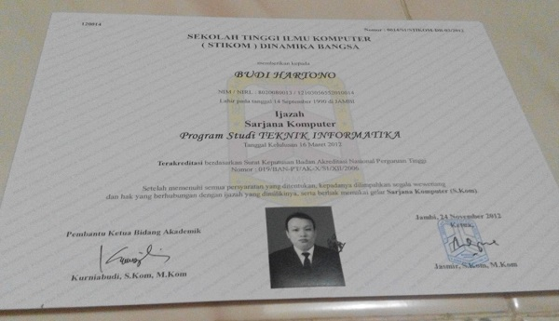

Fotocopy Transkrip Nilai

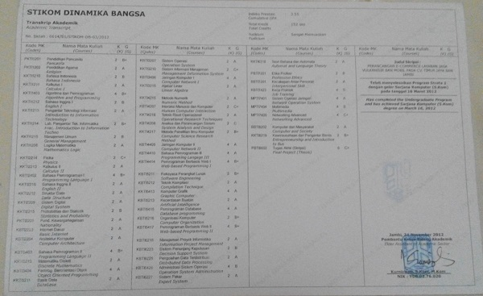

Fotocopy Certificate

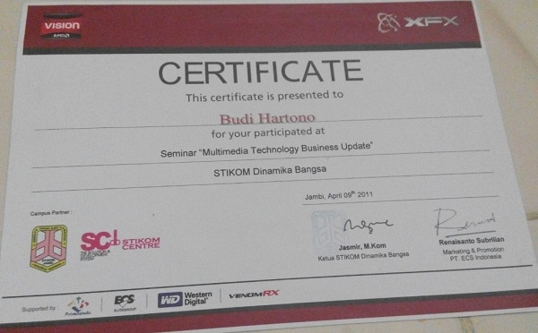

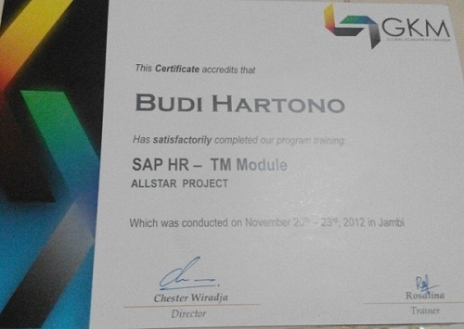

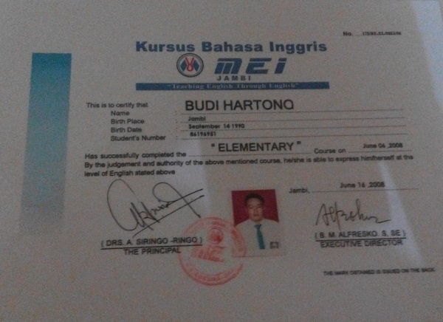

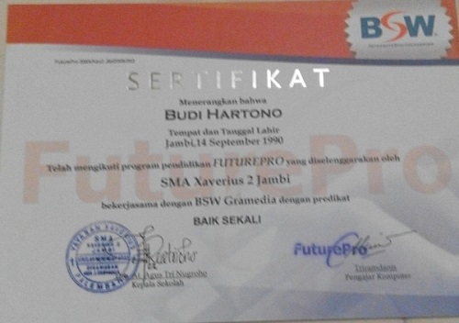

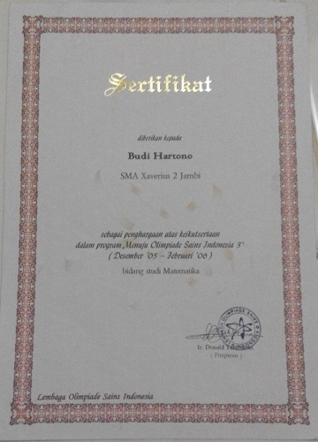

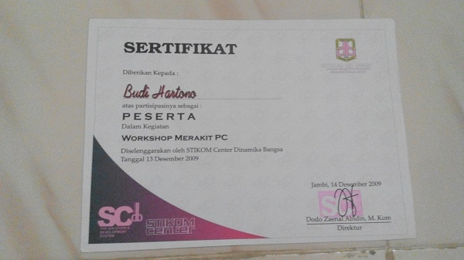

Fotocopy Work Experience Letter

